HOME
By Linda S. Buyer

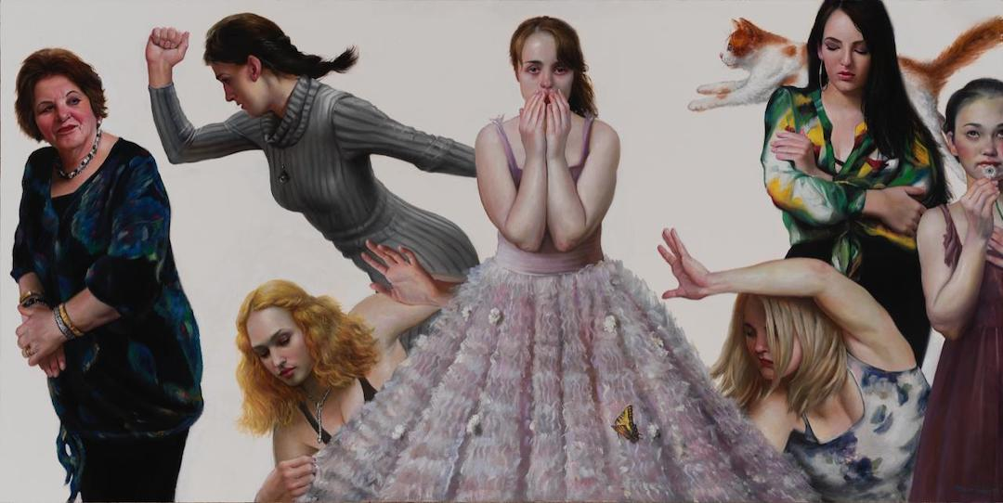Bruno Surdo – Growing Up (2018; Water-based Oil Paint on Paper Mounted to Board)

Home is the place I want not to be more than anything. It is the place where my parents scream at each other after lights out, when my sister and I are bedded down for the night in our shared room. It is the place where I can’t ever do what I want: where I can’t have the Halloween costume I want, where I can’t have long hair, where I can’t continue the ballet lessons I love because my “teacher isn’t good enough.” The place where I am never good enough.

Home is full of mid-fifties modern furniture. A wire armchair. A numberless starburst clock. An armless couch draped in plastic. It is a place that smells of nothing. The place where my mother stands guard with a vacuum cleaner when anyone decides to make popcorn. The place where she threw out everything in the pantry after finding a single sesame-seed-sized reddish-brown bug in a closed tin of McCormick paprika. The place where pets aren’t allowed because a turtle that escaped from the shallow, oval terrarium on the slatted wooden bench under the dining room windows came ambling back across the dining room floor, three weeks after he disappeared. Home has no houseplants. No sweets. Nothing to attract a butterfly.

Home is a place where no one ever touches another. No kiss or hug “goodnight.” No pat on the shoulder “good job.” It is the place where perfect isn’t good enough.

Home is a place to escape, reading late into the night, towel rolled up at the foot of the bedroom door. Books propose the perfect, rational worlds of Fountainhead and Walden Two. Introduce Caleb Trask, wrong just for being, my shadow twin. Books mostly have happy endings. Would there be so many if it were never true?

Home is the place I want not to be more than anything.

